Table of Content

Contents
1. Purpose 2
2. Scope 2
3. Responsibilities 2
4. Procurement Procedure Annexure B (process flow): 3
5. Supplier Selection & Evaluation Criteria: 6
Annexure 1 17
Purchase Requisition Form 17
Annexure 2 18
Process Flow for Petty Cash Purchases 18
Annexure 3 19
Price Comparison Form 19
Annexure 4 20
Annexure 5 21
Procedure for Goods stacking 21
Annexure 6 23
Vendor Selection Form 23
Central Purchase Committee (CPC) 24
Purchase Order (PO) Disbursement Policy 26
Price Competitiveness Policy 27
Procedures for disposal of Assets & Goods 28
Procedure for Scrap Material and/or Waste Disposal 29
Store – Process Flow 31
PROJECT MANAGEMENT – BUILD OUTS 32
ROLES & RESPONSIBILITIES 33
Rental Negotiation Committee 34

OBJECTIVES AND SCOPE
1.1.1 OBJECTIVES
i. To provide uniform policy and standard operating procedure for Selection of vendors /
suppliers.
ii. To enable Business Units to acquire material / Services of desired quality and delivery parameters
at competitive prices from approved vendors / suppliers.
1.1.2 SCOPE
This document is applicable on all entities of Zameen Development.
The purpose of this document is to provide a step-by-step guide and create an awareness for the procurement department to align all purchase activities with this defined procurement procedure to achieve the objectives of cost, quality, time, accountability and transparency.

ABBREVIATIONS

Abbreviation Description

AOP Association of Person
AVL Approved Vendor List
B/L Bill of Lading
BG Bank Guarantee
BOQ Bill of Quantity
CPC Central Procurement Committee
CNIC Computerized National Identity Card
CST Comparative Statement
GD Goods Declaration
I/C In charge
IB Indemnity Bond
IBAN International Bank Account Number
IGP Inward Gate Pass
IMS Integrated Management System
KPI Key Performance Indicator
LC Letter of Credit
MIS Management Information System
MOU Memorandum of Understanding
MRP Material Resource Plan
MS Method Statement
NTN National Tax Number
PO Purchase Order
PPM Project Procurement Manager
PQ Pre-qualification
PR Purchase Requisition
MR Material Requisition
ITB Invitation to Bid
PROC Procurement
QA/QC Quality Assurance and Quality Control
QTY Quantity
RFQ Request for Quotation
SOP Standard Operating Procedure
SRO Statutory Regulatory Order
STN System Track Number
SUBCO Subcontracting
UOM Unit of Measure
VAT Value Added Tax
HSE Health, Safety and Environment

3. Responsibilities
Head of Supply Chain
• Ensure completeness, accuracy and integrity of Master Data
• Review and approved Purchase Orders as per Financial Authority Limits Policy.
• Review and approve Pre-Qualification Form for vendors exempted from Pre-Qualification process
• Review master data entered in VM sheet.
• Review and approve master data change request
• Review and approve comparative statement for rate running contracts.
• Review and approve the Agreement with vendor.

Sr. Manger Procurement
• Review Vendor’s documents obtained for Pre-qualification
• Evaluate Vendor against Approved Pre-qualification criteria.
• Review Vendor’s Master Data on annual basis in order to ensure its completeness, integrity and accuracy.
• Inform Vendor about the evaluation criteria against which vendor’s performance shall be evaluated.
• Review and sign off the Vendor’s Performance Evaluation Form.
• Ensure all Open PO (i.e. Partially Open or Completely Open) which are no longer required are closed in the system on monthly basis.
• Maintain record of all information / data / documentation pertaining to procurement as referred in Supply Chain Manual.
• Generate Master Data Maintenance Report outlining actions taken during master data maintenance / cleansing activity and share it with Head of Supply Chain and Business Process Owner for their information.
• Review and approve manual comparative Statement for procurement through petty cash.
• Review and approve Purchase Orders as per Financial Authority Limits Policy.
• Responsible for overall record keeping and maintenance of all data
pertaining to procurement

Buying Specialist
• Negotiate terms and conditions of contract with concerned material /service provider.
• Request Vendor to provide required information on Vendor PQ Form along with all related documentation.
• Conduct visit (if required) of vendor’s premises to validate the authenticity of the information / documents provided by vendor and report their findings on Vendor Visit Report/ email record.
• Evaluate Vendor against PQ Criteria.
• Enter particulars of prequalified vendor and attach all related documentation in VM.
• Raise Master Data Change Request in VM to finance and update respective Master Data fields.
• Share Performance Gaps Report with vendor in case of unsatisfactory / unacceptable performance rating.
• Conduct Vendor Evaluation & upon completion record findings via vendor Performance Evaluation Form.
• Inform concerned vendor regarding blocking / blacklisting decision along with underlying reasoning and condition, vendor has to comply with in order to be unblocked / relisted
• Review PR for its completeness and accuracy and in case of any discrepancy, revert back PR within 24 working hours to Planning Department mentioning underlying reasoning.
• Generate RFQ with reference to PR within 24 working hours of receipt of PR.
• Float RFQ along with Technical Specifications and other Project information to prequalified vendors via e-mail keeping Sr. Manager Supply Chain & Head of Supply Chain in copy.
• Receive quotations from vendors & perform their commercial & technical evaluation
• Prepare manual comparative statement as per annexure 3.
• Mention underlying reasoning / justification in comparative statement in case quotations is not received from minimum three pre-qualified vendors or cheapest vendor is not selected.
• Initiate contract negotiation process and agree terms and conditions of vendor agreement with the supplier.
• Generate Purchase Order in Sage for selected vendor.
• Approved terms & condition (Legal) must be shared along with the PO including payment terms & delivery date.
• Obtain written acknowledgment from vendor against PO & In case confirmation is not received, execution of PO SOW by the vendor will be deemed accepted.
• Monitor vendor as per SOP and report any violation/non-conformity to Sr. Manager Procurement for further actions.
• Submit vendor’s invoice along with all supporting documents like PR, MD, PO, GRN, MIR, CPC approval.

*Aforementioned list is non-exhaustive and employees may have to perform additional roles and responsibilities as described in other policies, procedures, method statements and financial authority limits.

2 GENERAL POLICIES AND PRINCIPLES
2.1 PROBITY AND ETHICS POLICIES
2.1.1 CONFLICT OF INTERST
i. Employees shall avoid any conflict between their own interests and the interests of the Company, in dealing with suppliers, vendors, service providers, and all other organizations or individuals doing or seeking to do business with Zameen Development.
ii. While dealing with suppliers, vendors, service providers, and all other organizations or individuals doing or seeking to do business with the Zameen Development, potential conflict of interest may arise, for example, because of personal investments, employment of family members or previous employment relationships. At all times, those involved in procurement activities must avoid situations / business transactions which may lead to real or perceived conflicts of interest or allegations relating to the same.
iii. Zameen Development staff must declare, if aware, any business or personal relationships with family, relatives or friends employed by outside suppliers, vendors, service providers etc. quoting for Zameen Development Contracts to ensure vendor selection process is not compromised.
2.1.2 ANTI CORRUPTION, BRIBERY AND FRAUD
i. Bribery, Corruption and Fraud can be in breach of law and are contrary to Zameen Development’s Values and Code of Conduct. All Employees have a responsibility to comply with the law and to help protect and enhance Zameen Development’s brand and reputation.
ii. Employees shall not engage in, attempt, assist, encourage or ignore Bribery, Corruption or Fraud while dealing with suppliers, vendors, service providers, and all other organizations or individuals doing or seeking to do business with the Company or any affiliate.
iii. Employees shall raise any suspicion of Bribery, Corruption or Fraud, while dealing with suppliers, vendors, service providers, and all other organizations or individuals doing or seeking to do business with Zameen Development, in accordance with Zameen Development’s Whistle Blowing Policy.
2.1.3 GIFTS, HOSPITALITY AND ENTERTAINMENT
i. All staff involved in procurement activity or perceived to be in position that influences procurement decisions may not solicit or accept gifts, hospitality or entertainment from suppliers, vendors, service providers and all other organizations or individuals doing or seeking to do business with Zameen Development unless within Zameen Development’s Code of Conduct Policy on accepting gifts, hospitality and entertainment.
ii. At no time should gifts, hospitality or entertainment be accepted from suppliers who are tendering or negotiating for Zameen Development’s business.
iii. Any offer or supply of gifts, hospitality or entertainment regardless of value should be reported in accordance with Zameen Development’s Code of Conduct Policy. This provides transparency and enables assessment of any charge of impropriety made by competing suppliers, vendors, service providers, and all other organizations or individuals doing or seeking to do business with Zameen Development.
2.1.4 SEGREGATION OF DUTIES
i. Source to pay process is deliberately spread across stakeholders to ensure integrity is maintained.
ii. Employees involved in procurement activity should not have conflicting roles which leave them open to accusations of unethical behaviors.
2.1.5 MANAGEMENT OVERRIDE OF CONTROLS
i. Management override of Controls is strictly prohibited and shall amount to mis procurement (e.g. splitting Purchase Orders (POs) in order to avoid the approval thresholds)
ii. Manual approval of the authority, whose systematic approval has been forgone for cases where the splitting POs are Business needs, must be obtained & attached with the PO’s.
2.1.6 CONFIDENTIALITY
i. Applying strict confidentiality to vendor sourcing, contract negotiation and contract & supplier management is essential to Zameen Development’s supply outcomes and reputation in the market.
ii. All information, including commercial data on prices and other terms exchanged between Zameen Development and current / potential suppliers, vendors, service providers etc., must be treated as strictly confidential and shall not be disclosed beyond the relevant Supply Chain Team and appropriate stakeholders. Non-Disclosure Agreements must be used when sharing confidential information before an agreement is in place.
iii. Under no circumstances must data provided by one supplier, vendor, and service provider etc. to another in either written or oral form.
iv. Terms of a contract made with one supplier, vendor and service provider etc. must not be shared with its competitors.
2.1.7 COMPLIANCE WITH CODE
i. All staff is required to strictly comply with Zameen Development’s Code of Conduct while performing their Professional duties under this manual.
2.2 SOURCING AND CONTRACTING
2.2.1 SOURCING STRATEGY
1. Sourcing Policy
i. Zameen Development shall act as one organization instead of representing different Divisions / Business Units while dealing with vendors and shall maximize leverage by bundling all internal requirements before going to the market.
ii. Procurement shall be done through transactions with financially sound and reputable organizations that are capable of satisfying corporate needs.
iii. Material shall be procured at the most economical costs with timely deliveries without compromising on quality, reliability and controls.
iv. Business shall, to the greatest extent possible, be awarded on the basis of competition among qualified Suppliers.
2. Planning and Monitoring
i. Bidding and Proposal Department shall finalize material rates to be used for preparation of bids / proposal in consultation with Supply Chain Department.
ii. Once project is awarded, Planning Team shall, as a part of overall project budget, prepare budget for Procurement i.e. (Rev-00) which once approved shall be shared with Supply Chain Department.
iii. Material Resource Plan for whole project life shall be prepared within 3-4 Weeks of approval of Budget Rev-00. Thereafter, it shall be updated and shared with Supply Chain Department on quarterly basis.
iv. Performance of Supply Chain Department shall be evaluated against budget targets set in Project Budgets.
2.3 VENDOR / SUPPLIER MANAGEMENT
2.3.1 PRE-QUALIFICATION
i. No business shall be transacted with any vendors unless it meets recommended requirements for Vendor Pre-qualification as laid down in Vendor PQ Criteria
(Annexure 6).
ii. Vendor Pre-qualification shall be mandatory for all vendors except for the following;
a. Government Organizations / Regulatory Authority Department
b. Zameen Development’s sister concerns organizations
iii. Pre-qualification of vendor shall be valid for a period of two (2) years and subsequently each vendor shall again be subject to pre-qualification.
iv. No vendor shall be exempted from Pre-Qualification process of vendor, unless prior approval of Head of Supply Chain, Head of ZD is obtained on Single Source Form.
2.3.2 ON-BOARDING AND MASTER DATA MANAGEMENT
i. Only vendors meeting pre-qualification criteria shall be entered in the Vendor Master Data.
ii. Ownership of Vendor Mater Data shall rest with Sr. Manager Supply Chain.
iii. Vendor Master Data shall be reviewed on annual basis to ensure that:
a. Vendor Master Data is complete and vendors do not have any falsified information updated in the system.
b. There are no duplicate vendors registered in the Vendor Master Data.
2.3.3 PERFORMANCE EVALUATION
i. Performance evaluations of vendors shall be performed on Yearly basis.
ii. No business shall be transacted with vendors not having satisfactory performance rating
as laid down in Vendor Performance Evaluation Form. (Form To Be Attached)
2.3.4 BLOCKING AND BLACKLISTING
i. No business shall may be transacted with persons, organizations or entities who abuse the supply chain management system by committing a corrupt, fraudulent, unfair or irregular practice.
ii. Vendor shall be blacklisted based on true facts which lead to financial loss and damage the goodwill / reputation of the Company. However, repeated non-compliance of agreed terms and condition may also become a reason of blacklisting of approved vendor.
Circumstances leading to vendor blacklisting may include but not limited to the following:
a. Conviction of fraud, corruption, criminal misappropriation, theft, forgery, bribery or any other criminal offence;
b. Indulgence in corrupt and fraudulent practices while obtaining or attempting to obtain a procurement contract;
c. Final decision by a court or tribunal of competent jurisdiction that the contractor or supplier is guilty of tax evasion;
d. Willful failure or refusal to perform in accordance with the term/s of the Contract / PO / WO.
e. Failure to remedy underperforming contracts, as identified by the Zameen Development, where underperforming is due to the fault of the contractor, supplier or consultant.
f. Notified / suspended / debarred by Government Office or Public Procurement Regulatory Authority.
iii. No Blacklisted vendor shall be relisted in the Approved Vendor List without prior Pre-Qualification as laid down in Supply Chain Manual.
iv. Vendors may temporarily be blocked in case of minor issues / non compliances.
Circumstances leading to Vendor blocking may include but not limited to the following:
a. Unsatisfactory / Unacceptable Overall Performance Rating.
b. Not responding to the “Positive Balance Confirmation Request” from Company /Company Auditor.
c. Vendors having static balance for more than more than 1 year
v. Blacklisting shall be done at company level. However, blocking can be done at Company
/ Division / BU level at the discretion of CFT.
vi. The record of the blocked / blacklisted vendors shall be maintained and updated.
Further, it shall also be disseminated within the Zameen Development Group Entities via intranet
network.
2.3.5 FEEDBACK
i. Zameen Development shall obtain feedback from all active vendor in order to ensure that vendors’ views and comments are taken into consideration and positive actions are taken to continually improve relationship with vendor.
ii. Vendor’s feedback shall be obtained annually by IA and shared with Head ZD for appropriate actions.
2.4 REQUISITIONING AND PROCUREMENT
i. User department shall raise PR in Sage for material / items / asset to be procured and procurement process shall not be initiated without a valid PR raised by user department.
ii. RFQs shall preferably be floated to the pre-qualified vendors. However, quotations can be called from non-qualified vendors as well for comparison purposes.
iii. RFQs shall, to the greatest extent, be floated to all related vendors appearing in Zameen Development’s Approved Vendor’s List.
iv. At least three quotations shall be required from pre-qualified Vendors for comparative
analysis except in the cases where:
a. Vendor is client’s only approved / recommended vendor.
b. Only one vendor has responded to the RFQ (In this case RFQ must have been floated, to the greatest extent possible, to all available vendors in the Vendor Master Data and all correspondence shall be attached in CST with PO).
c. A long-term Agreement has been signed with the vendor provided that the process of three fresh quotations was complied with at the time of entering in an agreement with vendor. However, in case of rate running contract other quotations must be called for selection of most competitive vendors.
d. Vendor is the sole provider of the material / item under consideration.
e. Any Government / Legal requirement exists.
v. Quotations received from vendors should be converted into a CST.
vi. In case quotations are not received from minimum three pre-qualified vendor or cheapest vendor is not selected, underlying reasoning / justification shall be clearly mentioned in comparative statement.
vii. Purchase Order for procurement of material shall be raised through Sage. No procurement shall be initiated without prior approval of PO and written acknowledgement from the vendors.

2.5 REPORTING AND ANALYSIS
i. Performance of Procurement Section shall be evaluated on periodic basis and reported.
ii. Supply Chain MIS shall be shared with Head ZD as a part of Monthly Reporting Pack.
iii. Vendor Reconciliation shall be performed on biannual basis in order to:
a. Timely identify vendor invoices / credit notes not being received or processed
b. Prevent duplicate payments / over payments
c. Identify omissions / errors, if any, in both ledgers
d. Reduce vendor queries, improve relationship and prevent disruption of supplies
e. Validate balance sheet
f. Identify procure to pay issues

2.6 PROCESS GOVERNANCE
2.6.1 MANAGE PROCESS
i. Procurement policies and procedures shall be shared with all concerned employees against written acknowledgement.
ii. Compliance audit of procurement sections shall be conducted on annual basis in order to monitor overall procurement processes and check compliance against Supply Chain Manual.
iii. All information / data / documentation pertaining to Procurement as referred in Supply Chain Manual shall be retained with entry logs.
iv. Supply Chain Manual shall, at minimum be reviewed on annual basis in order to validate that it fits the needs of the business and to identify improvement opportunities.
2.6.2 SYSTEM MAINTENANCE
i. Head of Supply Chain shall be responsible to assign and / or revoke system access rights granted to employees. Access rights shall be reviewed on quarterly basis in order to ensure that they match with employees’ job description and segregation of duties is in place.
ii. System interfaces shall be tested annually to ensure that company policies and standards are enforced.
iii. Vendor master data maintenance / cleansing activity shall be carried out on annual basis in order to ensure that vendor information is complete, accurate and up-to-date and vendor master data does not contain any duplication.
2.6.3 DOCUMENT CONTROL
i. This Manual is a proprietary document of Zameen Development and should not be reproduced, changed, amended, used or copied within or outside the Company.
ii. Supply Chain Business Process owner shall be the custodian of this manual and shall be responsible for any updates and control of change.
2.6.4 DOCUMENT UPDATE
i. Any change in the contents of this document (addition, deletion or change in procedures) shall be subject to the original review / approval and distribution system as mentioned in the title of this manual. ( TO BE ADDED IN COLLABORTAION WITH IA )

3. Procurement Procedure

Annexure B (process flow):
Items are categories as per their sequence, nature and usage in the construction process. Mainly three categories are defined.
- Civil
- MEP
- Finishing
Further these categories can be converted into Functional & Non-Functional classes.

Sr. # | Equipment Description | Nature of the Equipment
1 | Elevator | Functional
2 | Chillers | Functional
3 | Hot water generator | Functional
4 | Escalators | Functional
5 | LT Panels | Functional
6 | Fuel transfer pump | Functional
7 | MEP Pumps | Functional
8 | Gensets | Functional

Sr # | Description | Nature of Equipment
1 | Aluminum Windows | Nonfunctional
2 | Kitchen Cabinets | Nonfunctional
3 | Wardrobes | Nonfunctional
4 | Doors | Nonfunctional
5 | Tiles | Nonfunctional
6 | Plumbing Fixtures | Nonfunctional
7 | AC's | Nonfunctional
8 | Geysers | Nonfunctional

Vendor Qualification

- Site Visit
- 5% of total spend of the project
- Top 25 vendors by spend
- QC will share rejection reports monthly basis
- IR’s will be shared to SC after duly signed by QS, QC, CM.

User department shall raise PR in SAP for material / items / asset to be procured and
procurement process shall not be initiated without a valid PR raised by user department.
ii. RFQs shall preferably be floated to the pre-qualified vendors. However, quotations can be
called from non-qualified vendors as well for comparison purposes.
Requisition: A system generated PR will be raised by concern department and in case of non-availability of system generated PR, it will be raised on a specified PR form (Ref annexure 1). It will be entertained upon submission to purchase (or store) department. It is the responsibility of the “Requisitioner” to generate requisition with all specifications, nomenclature, brand, model, make, description, quantity with required delivery date, otherwise it will be void. Procurement consists of the following two kinds.

- Monthly Purchase (Repeat Orders).
- Purchase on Demand.

4.1. Monthly Purchase (Repeat Order): Repeating items demands are processed on monthly basis. “Requisitions” are generated by procurement (IT equipment) and logistics team (only grocery & house-keeping) after compiling projected requirements for the whole next month with the objective to carry reserve stock to avoid stock out, to stabilize fluctuation in consumption, to have adequate materials on hand when needed, to minimize the inventory investment, to operate efficiently etc. Monthly requisitions will comprise the requirement of general supplies like Grocery, housekeeping, stationery and IT accessories.
4.2. Purchase on Demand:
For all on demand items purchase requisition will be generated by concerned department. With all documentary verifications and approvals.
4.3. Approval Procedure (Requisition):
4.3.1 Approval Procedure (Requisition)-For routine items:
For all routine on-demand items, approval of concerned departmental head will be required to process the PR. Requisitioner will arrange approval as per defined process
4.3.2 Approval Procedure (Requisition)-For non-routine items:
For all non-routine items which are having a specific nature and where PO cost is exceeding PKR 500,000 CPC approval is mandatory for the processing of PRs.

4.4 Petty/Low value Articles Purchase:
- Petty Cash Purchase (Up to PKR-15,000/-): Some items are purchased without adopting regular procurement procedures those are called as petty purchases. Procurement team member dealing with petty cash purchases will be responsible for all these purchases under the guidelines as per Annexure 2.
- 4.4.1 Procedure for Petty Cash Purchases:
Upon receipt of purchase request against petty cash, procurement team member will evaluate the request and will get 3 quotations from open market, quotations in a written form (any form of social media like WhatsApp, Skype etc.). After finalization of price, prescribed petty cash form will be filled with all required information and will be handed over to concern requisitioner/requester for approval from their HOD. Once it is approved/signed by concern HOD form will be approved by Director procurement to proceed the request. Once transaction is done all original documents will be handed over to finance team and a copy will be retained by procurement team.
4.5 purchases against purchase order:
For all items purchased against PO below procedure will be followed
4.5.1. Request for Quotation (RFQ): Upon receipt of purchase requisition procurement team will float RFQ to already approved vendors or float Tender document via print media, at least 3 comparative quotations will be finalized for further negotiation process.
One vendor will be shortlisted by adopting following procedure.
- A price negotiating call or meeting will be conducted by procurement department with the vendors.
- Negotiation will be based on; financial evaluation/competitive price, payment terms, product/ service quality, on time delivery, after sales services, warranties etc.
- Preparation of Comparative Statement, Negotiation Minutes, approval documents and conclusion is to be documented.
- Where CPC approval is mandatory. Approval from CPC committee will be considered as “final approval”.
Price comparison and negotiation is done and recorded via Annexure 3
4.6. Issuance of Purchase Order / Contract etc. Procurement department will solely be authorized to issue purchase order, contract, agreement or any other related documents mentioning all necessary details related to payment term, delivery location, etc with the signature of Manager Procurement or other authorized signatory to the vendor for supplies etc.
Work order is to be issued by the Admin department on the basis of rates negotiated by Procurement

4.7. Receipt and Verification of All of Materials: At the arrival of supplies, admin floor manager/security in charge will check the supplier documents, materials and issue the inward gate serial number and refer the vendor to store office or concerned persons. Receiver of the supplies is responsible to verify:
- Quantity / weight of the items received
- Specifications of material against PR
- Physical condition of the purchased items i.e. packaging whether its intact / damaged / leaked
- Compliance of handling instructions mentioned on the goods
- Expiry dates mentioned on the goods (where applicable)
- Goods serial # matching with packing/details provided (on all applicable items).
- Goods warranty details verification on applicable items (For IT equipment and Handsets IT department will conduct verification).
- In case of bulk items receipts, packing method will be verified and each box is to be checked for satisfactory confirmation of quantity as per delivery documents.
- Technical inspection will be carried out by designated technical team as per defined form
- Marketing collaterals & other items where concerned department inspection would be necessary will be carried out accordingly
In case of any discrepancies or nonconformance observed/found while inspection in presence of issuer, receiver will raise his/her concern with WHs senior management to obtain required assistance.
In such items where an inspection form is mandatory store in charge will inform all concerned persons for the physical inspection of received material as per Annexure 4 (inspection form). Once inspection is done inspection form will be filled and signed by all concerns.
Once all related formalities are fulfilled Store In-charge prepares Goods Receipt Note/General Stock Receipt through ERP System & update stock in the System.
Internal auditor audits the store on monthly basis, to monitor stock and inventory status.
Most of the goods received will require to be stored in Warehouse / on site store. The stacking of the goods will be done as per Annexure 5 (procedure for goods stacking)

All payment will be verified by Sr Manger Procurement and duly signed by Director Procurement for processing. For payment process following steps will be taken by concern procurement resource.

- After delivery of the products, the invoice should be cross checked against the PO of that particular order.
- A copy of PO will be attached with relevant documents (as per Annexure A), then forwarded to the finance Department.
- A copy of above set of documents will be kept in the record of the procurement department.

4.8. Taxes
In accordance with the requirements of the Income Tax Ordinance currently applicable in Pakistan.

5. Supplier Selection & Evaluation Criteria:
5.1. Pre-Qualification and Approval of Supplier
Zameen Media encourages different vendors to get registered and doing business with us. Zameen Media works only with those vendors who are falling in our list of approved vendors / suppliers. For the purpose of vendor qualification, a detailed criteria is adopted.
For the purpose of vendor qualification information about different vendors is received through internet, personal relation, media post, email etc.
Following is the detail of Prequalification process,
- Vendors are invited to submit the company profiles for prequalification.
- Profiles are reviewed and vendor evaluation is performed on following basis:
- Market reputation, experience and reference of other clients
- Credit facilities
- Price
5.2. Vendor Selection Criteria Annexure 6:
The first section includes the basic information about the Procurement Personnel selecting and evaluating the Vendor. The information is as follow;

a) ‘Prepared By’ includes the name of the procurement personnel filling out the Vendor Evaluation Form.
b) ‘Title’ includes the designation of the procurement personnel responsible for evaluation
c) ‘Date’ includes the date on which the evaluation is being carried out.
d) ‘Vendor Referred By’ includes the name of the personnel by whom the vendor is being referred by.

Vendor Information:
Vendor Information, includes;
a) Company Name
b) Company Address
c) City
d) Contact Number
e) ‘Type of Business’- Whether it is Retail, Manufacturing, or Services.
f) Contact Number and Designation of Vendor’s representative.

g) ‘Vendor Type’- Whether it is for recurring products, new products, or services.

Vendor Selection Criteria (Minimum Qualifying Score 30/60)
5.2.1. Tax Status
Tax status of a Vendor has a major impact and is therefore taken under-consideration while shortlisting vendors.
1) If a vendor is a ‘Tax Filer’ then five points will be awarded.
2) ‘Sales Tax’- If a vendor has a Sales Tax number, three points will be awarded.
3) ‘SRO’s/Exemptions’ (applicable for import vendors only) - If a Vendor is eligible for exemptions for certain products, an exemption certificate needs to be provided and will be awarded two points for this eligibility.

5.3. Supplier’s History and Past Record
An organization’s overall history and past record makes the vendor selection process smooth and efficient. While taking ‘company’s history and past record’ under-consideration, three of the following factors are evaluated;
  - ‘Total Number of Years in Business’- Vendors are scored based on the total duration of their existence in the industry. The scoring criteria is as follow;
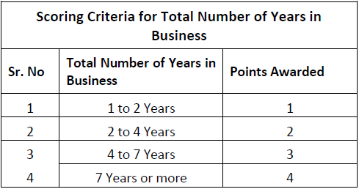

  - ‘Key Clients and Market Repute’- A supplier’s major clients reflect the ability and capability of a supplier to meet the overall demand. The overall presence and organizational structure will help in determining the significance of Vendor’s clientage. For each verified, satisfied client, a Vendor will be awarded one point. Having a strong overall market repute. A vendor’s overall market repute can be evaluated through;
a. Key Clients Reference Check: Conducting reference check of each key client will make it easier to evaluate vendor’s overall market repute. Against each reference check for a key client, the vendor will be awarded either ‘zero’ or ‘one’ point. The scoring system is as follow;
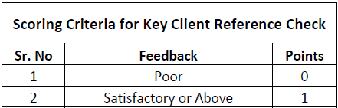

5.4. Payment Mode
Since, it’s the company’s policy to discourage ‘Cash buying’ and encourage ‘Purchase on Credit’, a vendor will be awarded a higher score if ‘credit payment terms’ are offered as opposed to a ‘score of zero’ if cash is the only mode of payment offered by the vendor.
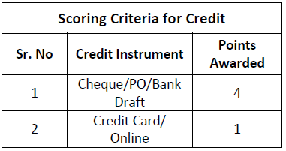

Furthermore, the flexibility of the credit line offered by the Vendor determines the number of points a vendor should be awarded. The scoring criteria is as follow;
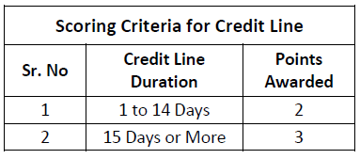
5.5. Company’s Registration Status
Score is awarded to Vendor based on its Company’s Registration Status. The scoring is as follow;

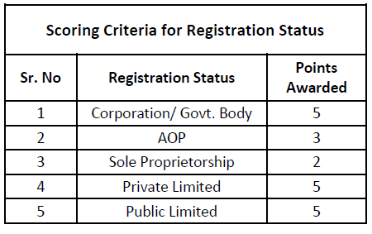
5.6. Company Setup Details and Analysis
Three important factors are taken under-consideration while evaluating a Vendor’s Business Setup. These factors include;
A) Vendor Footprint- The more spread out a Vendor’s business is in terms of geographical locations, more points will be awarded. Vendor’s Footprint is classified in to;

- Number of Offices: Vendor will be evaluated on the following criteria.

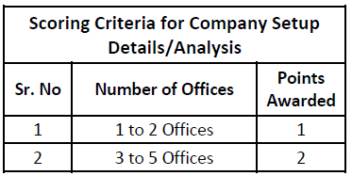

- Nationwide Existence: Vendor’s nationwide existence will be evaluated from its presence in metro cities and will be scored according to the criteria as shown below;

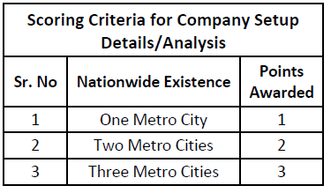

  - Workforce Strength- A vendor’s overall workforce strength depicts its ability to meet demand constantly and providing overall strength to an organization. Higher workforce will result in higher points. The score distribution is as follow;
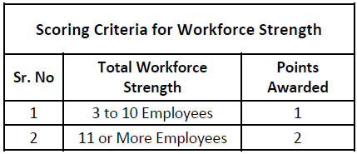

c) Capability to fulfill demand: A vendor’s capability to meet the customer requirements will be evaluated by its capacity to fulfill the order and its transportation system. The scoring criteria to evaluate a vendor’s capability to fulfill demand is as follow;
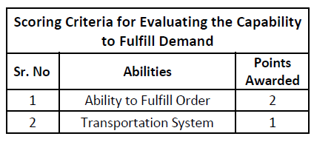
5.7. Terms and Conditions:
1) Market Competitive Pricing: During the ‘Vendor Selection Process’, it is of utmost importance to make sure that the prices, quoted by the vendor, are market competitive. This will be done through thorough market research. If the prices quoted by the vendor are market competitive, lower than or equal to, the vendor will be awarded ‘four’ points, otherwise the vendor will be awarded with ‘Zero’ points.

2) Availability of Support Staff: The availability of support staff measures the competency of the overall level or services provided by the vendor. This includes; availability of the technical support staff, overall response time, and the cooperation of the support staff. If the vendor has an adequate number of after sales support staff, then the vendor will be awarded ‘two’ points.

3) ‘Refunds for’ OR ‘Replacement of’ Rejected Items: Vendors who provide refunds for or replacement of rejected items will always be more preferable by the customer as opposed to the vendors who don’t. For instance, if a product delivered has been deemed ‘rejected’ due to quality constraints, a vendor who offers refunds (In case of non-replacement) or replacement for the specific product will be awarded ‘four’ points as opposed to the vendor who does not entertain refunds or replacement of the items delivered.

5.8. Internal Reference
If a vendor has been referred by an employee of the organization, points will be awarded to the vendor ‘out of five’. ‘Name, Designation, and Department’ of the employee will be recorded by whom the vendor has been referred. Vendor referred by an employee will be awarded points according to the designation of the employee. The relative scoring is as follow;

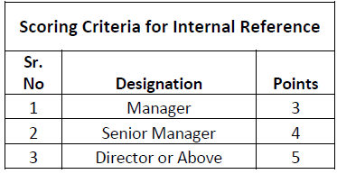

5.9. Vendor Evaluation Process:

After being selected, Vendor’s performance will be evaluated annually. Vendors will be evaluated and awarded points accordingly based on the following criteria

Scoring Criteria for Evaluating Vendor's Performance
Rating | Points Awarded | Description
Unsatisfactory | 0 | Vendor fails to deliver on quality, price & time
Development Needed | 1 | Vendor has potential to deliver but needs guidance
Satisfactory | 3 | Vendor is consistent on quality, price and time
Exceptional | 5 | Vendor is consistent in services / products at a min profit with the realization of becoming a business partner rather than a supplier

Each criterion, part of the Vendor Evaluation Criteria, has been assigned a weighted average. The overall score of the Vendor Evaluation is calculated based on the weighted average. The overall qualifying score is 50/100. The weighted average of each criterion is as follow;

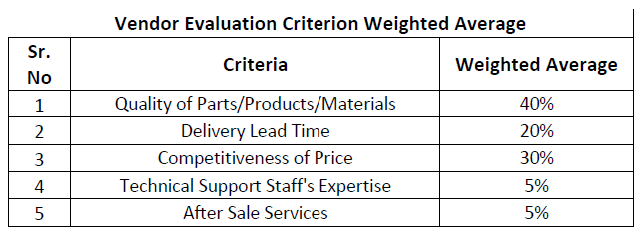

PARAMETER |  | CRITERIA | WEIGHTED  AVERAGE
1 | Quality of Product/Service | 0-1 Complaint---------40  2-3 Complaints--------30  4-5 Complaints--------20  6-7 Complaints--------10  7-10 Complaints-------0 | 40%
2 | Delivery Lead Time | 100% on time---------20  80% on time----------15  60% on Time----------10  40% on Time-----------8  20 % on Time-----------4  0% on Time-------------0 | 20%
3 | Price Competitiveness | Cost Analysis | 20%
4 | Order Fulfillment | 5% cancel Po----------8  10% cancel Po---------4  Above 10%-------------0 | 10%
5 | After Sales Service | Repair/Technical support/Return | 5%
6 | Credit Offered | 30-45 Days------5  20-30 Days-------4  10-20 Days-------3  5-10 Days---------2  COD-----------------1  Advance-----------0 | 5%

Vendor’s performance will be evaluated by taking the following criteria under-consideration;

5.10. Delivery Lead Time: It is the vendor’s ability to fulfill the order within the desired time. As the ‘required delivery date’ is mentioned on the PO generated against a specific order, the ‘required delivery date’ should be cross-checked against the date on which the product was actually delivered. The vendor will then be evaluated on the criteria below;

Delivery Lead Time Scoring Criteria
Sr # | Scenario | Points Awarded
1 | All deliveries were before time | 5
2 | All deliveries were on time | 4
3 | 80 % deliveries were on time | 3
4 | 50 % deliveries were on time | 2
5 | 30 % deliveries were on time | 1
6 | less than 30 % deliveries were on time | 0

5.11. Competitiveness of Price: Vendor will be evaluated based on the prices being offered in comparison with the prices being offered by other vendors. ‘Price Comparison’ should be conducted after every two months by taking 3 quotes to make sure the prices being charged by the Vendor are market competitive. Vendor will be evaluated on the competitiveness of price based on the following criteria;

Competitiveness of Price Scoring Criteria
Sr # | Scenario | Points Awarded
1 | 10 % below Average Market Price | 5
2 | 5 % below Average Market Price | 4
3 | Same as Average Market Price | 3
4 | 5 % above Average Market Price | 2
5 | 10% above Average Market Price | 1
6 | Greater than 10 % Average market price | 0

5.12. Quality of Parts/Products/Materials and Services: After the delivery of a product and/or rendering of services, an inspection is carried out against which an inspection form in filled out to determine if the products supplied or services rendered meet the quality standards. Each inspection form will be able to determine supplier’s overall performance.
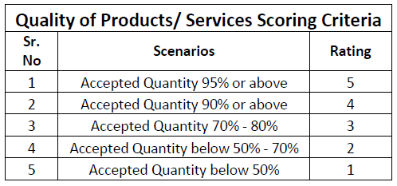

5.13. Technical Support Staff Expertise: Some products require technical expertise in order to be setup properly before use. A vendor’s overall ability to provide adequate technical support staff will be evaluated as;
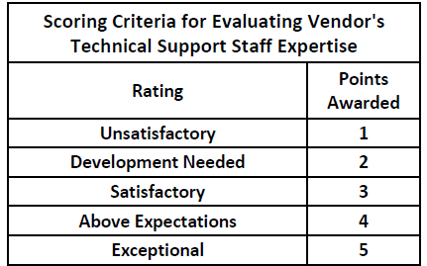

5.14. After Sales Services: It comprises of warranty claims, complaint handling / response, refunds and how well a vendor has been able to accommodate the customer in these areas. The vendor should be able to respond to all customer queries within the desired time to make it a hassle-free process. A vendor will be evaluated on how quickly and effectively the vendor has been able to resolve customer’s queries.

6. Related Documents:
Relevant Forms and Process flows: All relevant forms and process flows are attached below. Further to below attachments there is a document ZAM/PUR/PF-01, which contains all process flows.

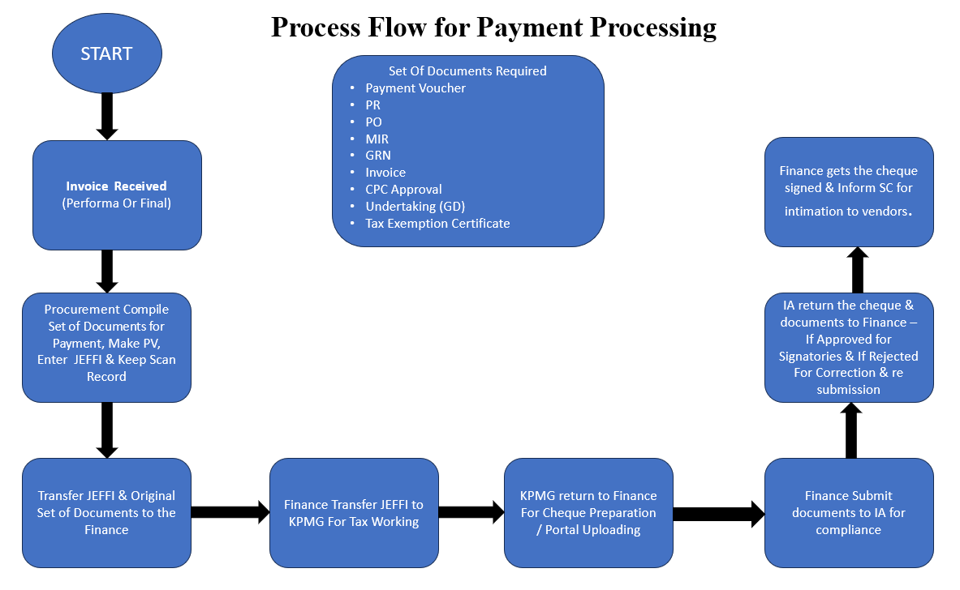

Annexure 1

Purchase Requisition Form

 |  |  |  |  | Purchase Requisition |  |  |  |  | Document Date:
Pearl One |  |  |  |  |  |  |  |  |  | Required Date:
94-B/1, MM Alam Road, |  |  |  |  |  |  |  |  |  | Document No:
Gulberg III, Lahore 54000
Punjab, Pakistan
Department |  | Description / Comments |  |  | Req Location |  | Required By |  | Approved By |  |  | Approval Status
 |  |  |  |  |  |  | Additional
Sr. No | Item Code |  | Description |  |  |  | Comments |  | Qty | UOM |  | Unit Cost | Total Cost | In Stock
1 |  |  |  |  |  |  |  |  |  |  |  |  | -
2 |  |  |  |  |  |  |  |  |  |  |  |  | -
3 |  |  |  |  |  |  |  |  |  |  |  |  | -
4 |  |  |  |  |  |  |  |  |  |  |  |  | -
 |  |  |  |  |  |  |  |  |  |  |  |  | - | -
Document Comments:
HOD / Regional Head
Sign: |  |  |  | Date:
Stamp: |  |  |  | Time:
*As per the Instructions of Management for approvals, 'Stamps', 'Date', 'Time' are compulsory to ensure compliance.

Annexure 2

Process Flow for Petty Cash Purchases

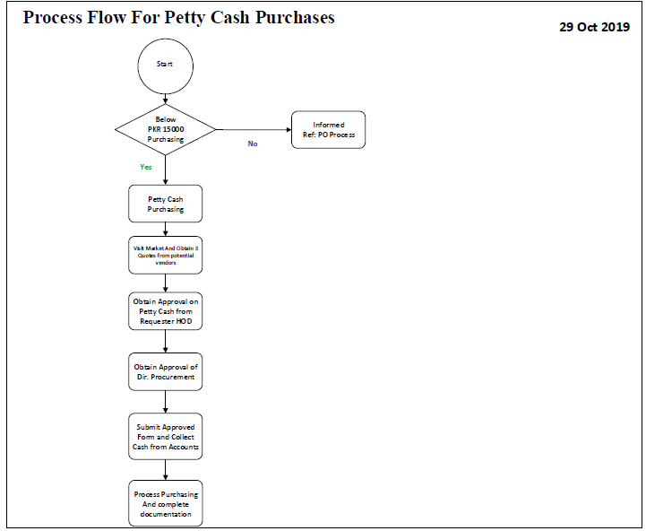

Annexure 3

Price Comparison Form
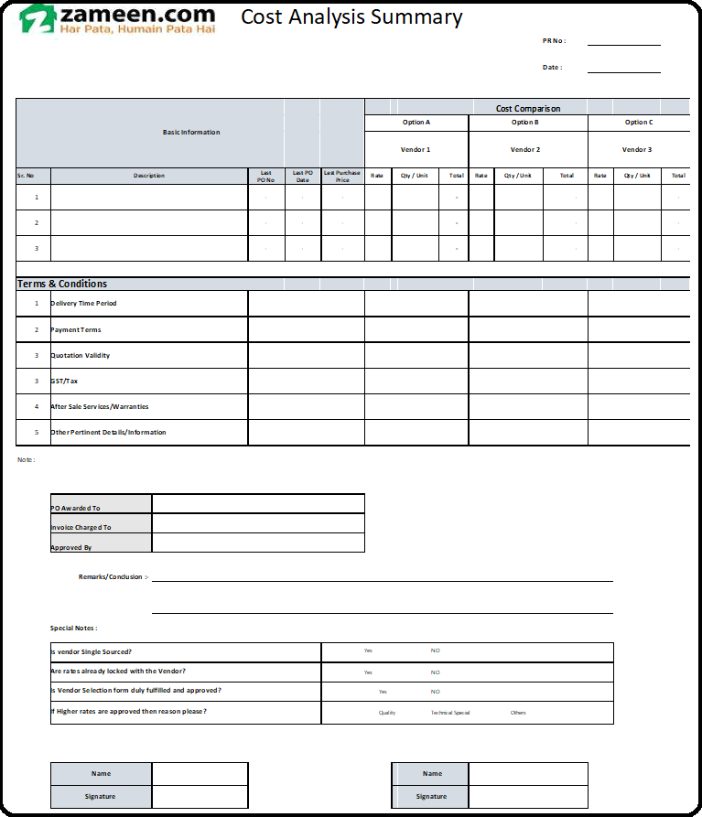

Annexure 4 Goods Inspection Form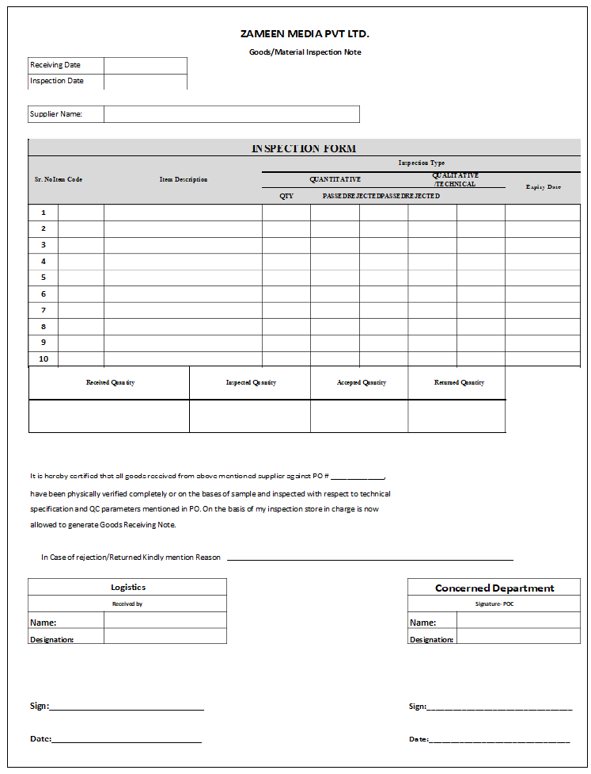

Annexure 5

Procedure for Goods stacking
The following procedure is to be followed to stack goods while in storage as well as when they are in transit.
Goods Stackable Area: Handling must adhere to the type of goods that is being handled. Its material, dimensions, handling instructions, weight and category must be kept in mind. Stacking needs to be done keeping a few factors in mind to ensure efficient execution of inbound and outbound activities. The warehouse design layout would make the job easier for smoother proceedings.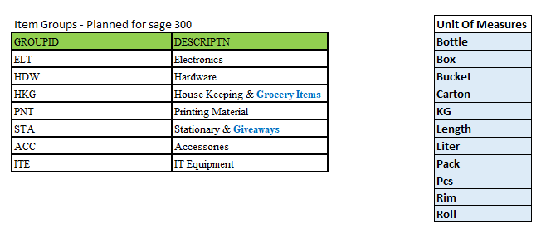

Goods Stacking Guidelines
- Areas will be specified for these items in all warehouses considering inbound & outbound frequencies.
- Warehouse layout design and category-wise indicators/tags will serve as guidance for appropriate stacking.
- Goods will only be stacked in designated stackable areas.
- Goods will be stacked to maintain FIFO method to ensure dissemination and depletion of items in chronological order (i.e. in sequence of arrival date and time).
- Goods will not be stacked near wires and electrical appliances.
- Goods will not be stacked near doors/walkways.
- Goods stored at height will be handled with portable stairways to ensure safe handling.

- Goods of heavier weightages will always be kept on ground storage/or on ground-level shelves of racks.
- In case of high volume and to cater for severe contingencies, the aisle area may be utilized. Slow moving goods will be placed here, and based on historic data, decisions will be made in consultation with the warehouse management team.
- Liquid items will be stacked on wooden pallets in their respective category of goods with handling instructions as mentioned on the goods.
- Handsets, laptops, and all high-value goods will be stacked in strong cabinets/strong rooms for strict monitoring with the appropriate entry and exit management.

- Handling of goods will be done with hand-jack pallets in case of heavy loads stacked on a wooden pallet.

- While stacking of goods on heights, careful judgment would be required to avoid tilting and collapsing of goods.

- In order to manage efficient use of space and appropriate stacking, in-house support or that of packing services will be acquired as and when required.
- Empty boxes should to be stacked in a separate area away from areas with inventory along with other related tools, such as cutters and packing tapes.
- While stacking, proper distance will be maintained to avoid mixing and stumbling of goods.
- Only authorized persons will be allowed to enter inventory stacking areas. Unauthorized entry/movement in inventory stacking area will be considered a severe violation and action will be taken according to the stipulated policies.
In case new goods arrive at the warehouses, stacking instructions will be communicated to all warehouses for strict compliance.

Annexure 6

Vendor Selection Form

Central Purchase Committee (CPC)

Engagement Limit:
Procurement of Goods
- Greater than or Equal to PKR 500,000.
- If the value is below PKR 500,000 Procurement Department will take the decision independently as per the defined authority matrix.
Mandate:
- Any transaction including but not limited to:
  - SLA
  - Service Contracts
  - AMC (Annual Maintenance contract)
  - Buildouts
  - Onetime Purchases
  - Exceptional Purchases (Must be approved by CEO)

Composition Committee Members:
Member | Designation | Type
Mariam Saleem | Head of ZD | Permanent Member
Shahid Hassan | Director IT | Permanent Member
Faisal Mir | Head of Supply Chain | Permanent Member
Tanzain Shafqat | Head of Finance | Permanent Member
Haseeb Malik | Head of Marketing | Permanent Member
Basil | Associate Director Audit | Observer
Haroon Noon | Director Design | Permanent Member
Adil Kamal | Head of Acquisition | Permanent Member
Head of Requisitioner Dept. | Concerned department | -

Meeting Frequency:
- Every Thursday followed by management committee meeting.
- CPC shall convene as and when the need arises. HOD procurement or Admin shall be responsible to arrange meeting of the CPC.

Quorum Compliance:
- At least 3 permanent committee members must be present in addition to the Head of the requisitioner department.
Alternatively, all cases are to be presented by head/ nominated proxy of requisitioner department, failing which, case shall be deferred to next CPC.

Terms of Reference of CPC Committee:
The terms of reference of CPC Committee shall be as follows:
- Develop an overall governance structure for the procurement function and recommending; standard operating procedures and key performance indicators to ensure fair, competitive and transparent procurement;
- Evaluate and review the need assessment of the desired procurement.
- Selection of the vendors based on the quote analysis / comparative statement, environmental impact and technical evaluation including assessment of similar deployments, product experience and market reputation;
- Approval of Contract / Purchase Order with the selected supplier for purchases value exceeding PKR 500,000 based on technical, financial and legal implications of proposed contracts.
- All purchases above PKR 1,500,000 are to be approved by Office of CEO.
- A mechanism to evaluate suppliers as per management objectives and review of the supplier evaluation results to ensure that only fully qualified suppliers of specific fields are retained by Zameen Development Pvt. Ltd
- Ensure minimization of procurement costs by directing the procurement function to negotiate bulk discounts with suppliers while ensuring quality.
- Take any decision with respect to procurement of goods and services as directed or delegated by the Office of CEO.
Services Acquisition or maintenance for Admin:
- Any acquisition of services not falling under the domain of Central Purchase Committee (CPC) will be fall under the domain of admin. However, before raising any work order it needs to be reviewed and approved by Internal Audit Department before the finalization of the order.

Decision Mechanism:
Once the quorum finalizes any decision, it is the responsibility of HOD Procurement or use dept (admin, HR etc) to share detailed email against the decision made to the committee members keeping office of CEO in loop. This approval email shall be attached with the standard documentation trail required to initiate any payment request through Finance.

Purchase Order (PO) Disbursement Policy

Purpose: This document is describing various touch points where (PO) purchase order would be required to disburse to substantiate pertinent process.
Procurement to Vendor: After receiving the purchase requisition, potential vendor identification, vendor/source identification, request for quotes, cost analysis, and subsequent approvals. PO will be generated against the specific requisition before placing an order to the vendor by respective buyer in Procurement Department
Procurement to Logistics: Logistics will be informed through copy of PO regarding shipment in pipeline to align necessary arrangement with regards to receipt and storage of goods.
Procurement to Accounts/Payables: After delivery of the products, the invoice should be cross checked against the PO of that particular order. A copy of PO will be attached with the requisition along with the invoice received and GRN processed. Complete Set of Documents will be forwarded to the Accounts Department.
PO Copy for Record Keeping: A copy of PO will be kept for record by Procurement, Logistics and Accounts Department.

Price Competitiveness Policy

Purpose: The purpose of establishing this SOP is to provide basic guidelines for buyers to ensure appropriate controls and define parameters for decision making and achieving competitive prices for all acquisitions.

Procedure: In order to ensure cost effective buying robust data management would be necessary to provide guidance to buyer for analyzing price competitiveness for every acquisition.

- Last buying price will be reviewed
- For imported items international and local market prices will be analyzed through authorized suppliers/distributors.
- Single sourcing options will be evaluated based on the volumes.
- Check International Prices (for imported items)
- Check Prices from Local Vendor/Clients (both for imported and local items)
- Multiple sourcing options will be evaluated based on the volumes.
- Minimum of 3 quotations from approved vendors.
- Cost Analysis Summary
- New vendor inductions completing all pertinent prerequisites.
- For emergency purchases price competitiveness may not be considered in detail. (Ref: Head Office 2nd floor renovation and other related installation in shortest possible time due to high business criticality)

Procedures for disposal of Assets & Goods

Objective: Scrap Material Policy

During the course of business, the regional business units generate amounts of waste / redundant, scrap, and reusable material that may be of value to the organization. Although the material may be easily identified as waste, the organization retains the right and the obligation to dispose of it in accordance with applicable policy.
Ownership and Control Regional Business units are responsible for the proper use, protection and disposal of Zameen Media Pvt. Ltd/Imzee Consulting Pvt. Ltd/Zameen Development/Deevar Developers Pvt. Ltd. property in their custody. Definitions Property is defined as any capital or non-capital tangible item purchased, donated, or acquired through trade, regardless of value or condition. Property includes all real estate, equipment, furniture, materials, supplies, inventory stock, or any item that may be used or sold.
Scrap materials are discards or byproducts generated from installation, repair, remodeling or construction activities. Metals such as copper, brass, stainless steel, aluminum, and iron are acceptable. Scrap materials include, but are not limited to:
• Laptops & Desktops – Including all peripherals
• Handsets
• POS Material
• Giveaways (Gift Items)
• Copper wire and cable
• Copper and steel pipe
• Electric motors
• Plumbing fixtures
• Steel duct work
• Electrical equipment and parts
• Decorative metal fixtures
• Vehicles

Procedure for Scrap Material and/or Waste Disposal
Material that is considered waste or is unusable remains the responsibility of Zameen Logistics department. As such, it is incumbent on all employees to ensure that the waste material generated through misc. operations and construction is disposed of in accordance with the appropriate procedures for that type of material. SCM shall observe the following when disposing of scrap materials or waste:
Property and/or scrap material, as defined above, is to be collected and delivered to the regional hub, or disposed of in accordance with suitable handling procedures for the material being discarded.

Process | Action | Process Owner
Physical Inspection of Scrap Material | Physical Inspection Report will be maintained. | Admin Department Related Department /Logistics/Internal Audit
Snaps of Scrap Material | A pictorial evidence of all available scrap material is required for record and working. | Admin Department
Material Financial Factor | Finance will determine and give feedback for the depreciated value & residual value. | Finance
Approval from Committee/Committee Member  In case of insignificant value/quantum after consulting with relevant/concerned business head | SCM will present complete report for the scrap of material and will seek approval. | Procurement
RFQ For Tender / Quotes | Depending upon volume, quotes will be required & assessed afterwards. | Procurement
Sale of Scrap Material | Scrap activity will be done in the presence of IA, Finance, Admin, Procurement and Logistics. | IA, Finance, Procurement, Logistics & Admin
Pictorial Evidence of Activity | The scrap activity must include a pictorial evidence for record. | Procurement/ Admin
Write Off / Salvage Value | Finance will update FAR at their end & inventory will update its records accordingly. | Finance / Logistics
Conclusion Report | A comprehensive report will be submitted by IA to Committee | IA

Failure to follow this Policy or the Scrap Material Control Procedure may result in disciplinary action, up to and including, termination.
Scrap Material Enforcement Procedure: To accomplish the objectives of the Scrap Material Control Policy, all Zameen departments and business unit managers shall:
1. Review this policy and procedures with employees in the unit. Documentation of this review shall be maintained by the unit.
2. Incorporate a review of this policy into the business unit new employee orientation briefing.
3. Periodically review material disposal procedures and practices to ensure that scrap material is delivered to the regional hubs (if required) for recycling receptacles, or handled in accordance with suitable procedures for the material being disposed of.
4. Enforce policies on acceptable use, disposal, transfer and recording of property location, inventory counts, and physical security measures.
5. Report theft, loss, or disappearance of Zameen property immediately to Admin.

Store – Process Flow
Goods Receiving Flow
1. Inward gate pass (filled by Security guard, as and when required)
2. Technical, qualitative and quantitative Inspection of incoming goods, as per the following chart:
Inspection Type | Stationery | Giveaways | Furniture | Housekeeping & Grocery | IT / Network / Mobiles | Electronic Appliances | Printed Collateral
Technical | Store | Store | Admin | Store | IT | Admin | Store
Qualitative | Store | Store | Admin | Store | IT | Admin | Store
Quantitative | Store | Store | Store | Store | Store | Store | Store

3. If incoming goods pass inspection, Store Manager will proceed to Step 4. If inspection fails, a Return-to-Vendor (RTV) document will be lodged by the relevant inspector within the ERP.
4. Goods Received
Good Receiving Process:
1) Intimation by Proc department
2) Inward Gate pass
3) Delivery
4) Receiving count / Under taking
5) Inspection
6) GRN
Store Keeping:
New Items | Employee Return
Asset Tagging | Store Receiving note
Stacking & Sorting & Movement across regions | Inspection (Only IT equipment will be inspected)
 | Fails inspection; sent to the Repair and Maintenance Dept.
 | Pass Inspection; Store Manager will proceed to the next step i.e. Stacking & Inventory
Issuance Process (Stock out)
a. Issuance may only happen against PR form.
b. Issuance Slip must be signed by Receiver (User Department)
c. Store Manager must update “Exit from Inventory” and check balance against minimum stock level (for recurring items).
d. If minimum stock level has been reached, the Store Manager will alert the relevant Proc associate and a PR/PO will be issued subsequently.

